European Youth Ultimate Championships 2017

Championship
View full bracket results
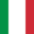
ITA U20 Men's
1st
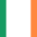
IRL U20 Men's
2nd
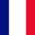
FRA U20 Men's
3rd
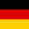
GER U20 Men's
4th
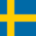
SWE U20 Men's
5th
LAT U20 Men's
6th
CZE U20 Men's
7th
SUI U20 Men's
8th
POL U20 Men's
9th
ISR U20 Men's
10th
BEL U20 Men's
11th
GBR U20 Men's
12th
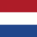
NED U20 Men's
13th
SLO U20 Men's
14th
AUT U20 Men's
15th
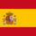
ESP U20 Men's
16th

